# **Deploying Apache Web Server with MySQL Integration**

# **1.Launching the EC2 Instance**

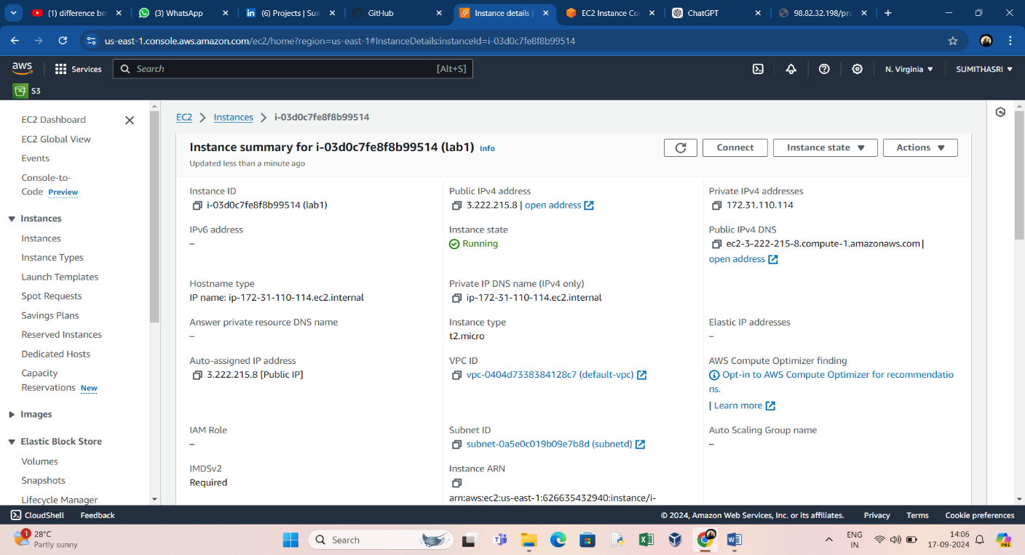

# **2.Create Security Group**

* Allows SSH Traffics
* Allows HTTP , HTTPS and MySQL Traffics along with Ports.

3. **Install Apache web server:**

* Open a terminal.
* Use the following commands to install Apache:

sudo apt update

sudo apt install apache2

* Apache web server will be installed on your system.

**4. Check the version and service status of Apache web server:**

* To check the Apache version, use the following command:

apache2 -v

* To check the status of the Apache service, use:

sudo systemctl status apache2

**5. Create a simple HTML app that can talk to the MySQL database:**

* Use a text editor to create an HTML file (e.g., **index.html**):

sudo rm -rf /var/www/html/index.html

sudo vim /var/www/html/index.html

* Add a simple HTML form to the file. For example:

<!DOCTYPE html>

<html>

<head>

    <title>MySQL App</title>

</head>

<body>

    <h1>MySQL App</h1>

    <form action="process.php" method="POST">

        <label for="name">Name:</label>

        <input type="text" id="name" name="name">

        <input type="submit" value="Submit">

    </form>

</body>

</html>

* Open a web browser on another computer or device.
* Enter the IP address of your Ubuntu 20.04 machine in the browser's address bar.
* You should see the "MySQL App" page.

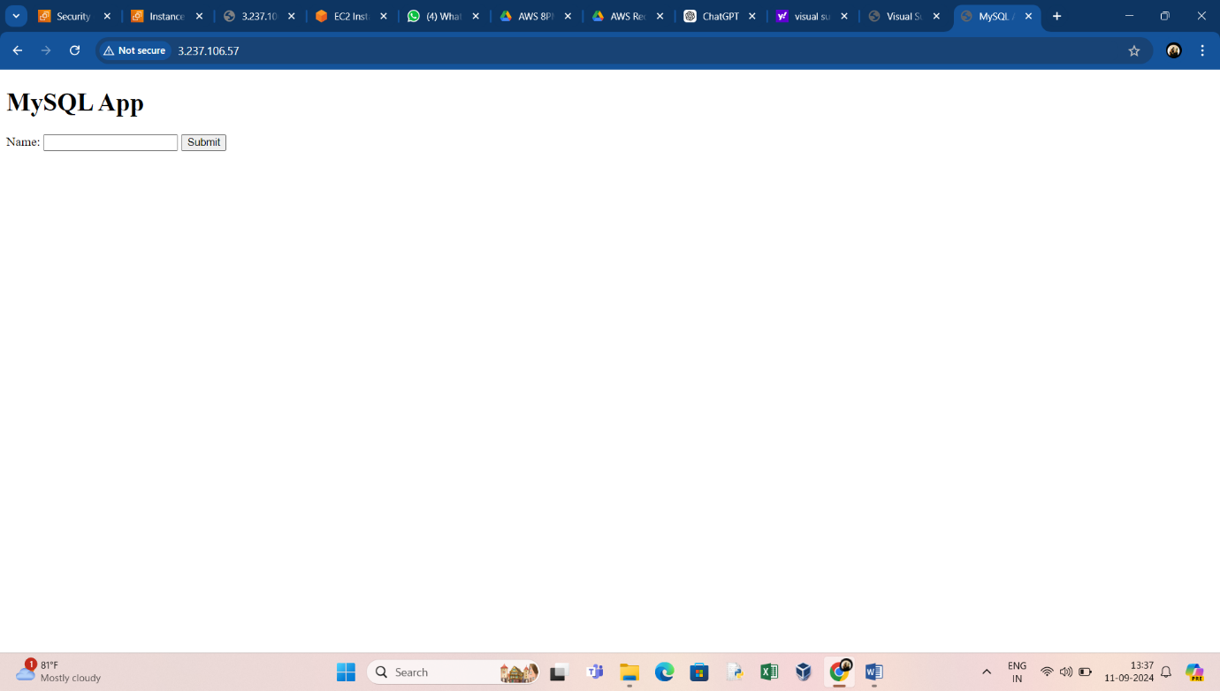

**6. Install MySQL and check its status and version:**

* Use the following command to install MySQL Server:

sudo apt install mysql-server

* During the installation, you'll be prompted to set a MySQL root password.
* To check the MySQL version, run:

mysql --version

* To check the status of the MySQL service, use:

sudo systemctl status mysql

**7. Create a database and a table in MySQL:**

* Log in to MySQL as the root user:

mysql -u root -p

CREATE USER ‘yourname’@localhost’IDENTIFIED WITH mysql_native_password BY’yourpassword’;

* Enter your MySQL root password.
* Create a database and a table, and grant privileges to a user (replace **<your_database>**, **<your_table>**, **<your_user>**, and **<your_password>** with your preferred values):

CREATE DATABASE test;

    USE test;

    CREATE TABLE testtable (

        id INT AUTO_INCREMENT PRIMARY KEY,

        name VARCHAR(255) NOT NULL

    );

    CREATE USER 'vboxuser'@'localhost' IDENTIFIED BY '1234';

    GRANT ALL PRIVILEGES ON test.* TO 'vboxuser'@'localhost';

    FLUSH PRIVILEGES;

**8. Create a PHP script to connect the app and MySQL DB:**

* Install PHP if not already installed:

sudo apt install php

* Install this extension

sudo apt-get install php-mysqli

* Create a PHP script (**process.php**):

nano /var/www/html/process.php

* Add PHP code to connect to the MySQL database and insert data (replace placeholders with your actual values):

<?php

$servername = "localhost";

$username = "<your_user>";

$password = "<your_password>";

$dbname = "<your_database>";

$conn = new mysqli($servername, $username, $password, $dbname);

if ($conn->connect_error) {

    die("Connection failed: " . $conn->connect_error);

}

$name = $_POST["name"];

$sql = "INSERT INTO <your_tablename> (name) VALUES ('$name')";

if ($conn->query($sql) === TRUE) {

    echo "Record inserted successfully!";

} else {

    echo "Error: " . $sql . "<br>" . $conn->error;

}

$conn->close();

?>

**9. Access the site with the IP of the Ubuntu box:**

* Open a web browser on another computer or device.
* Enter the IP address of your Ubuntu 20.04 machine in the browser's address bar.
* You should see the "MySQL App" page created in step 5.
* Fill in the form and submit it to insert data into the MySQL database.

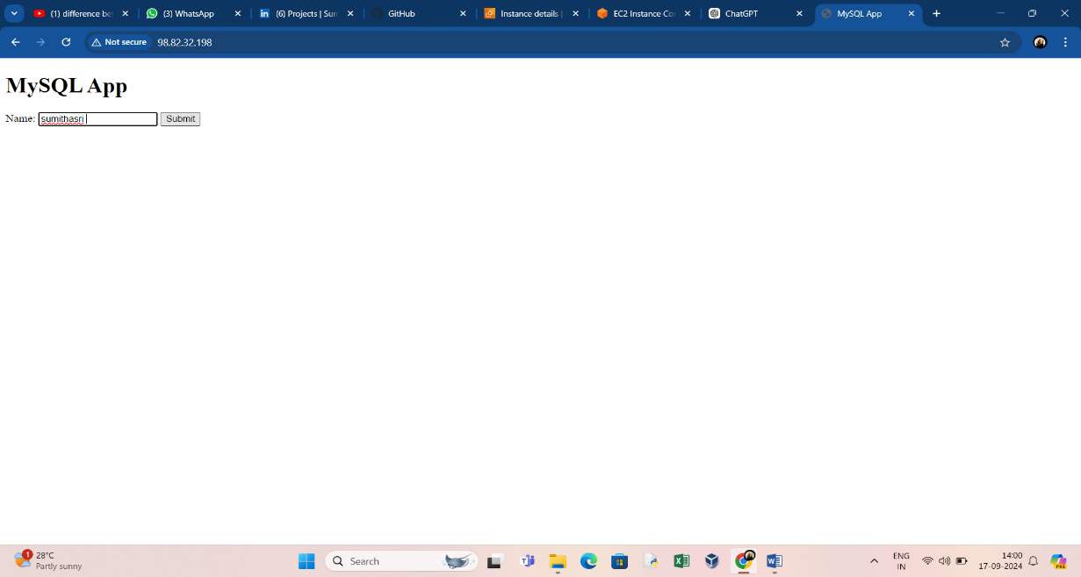

* Data’s are stored in MySQL database .

